THE REMEDIE ROOMS

HEALTH & BEAUTY

DAY-SPA FOR MEN & WOMEN

YOUR LOCAL AWARD WINNING SINCE 2006
NATURAL NAIL LOUNGE, DAY-SPA & BEAUTY SALON


…WE PROVIDE WELLNESS…

6 Streatham High Road
London, SW16 1DB
Tel: 07511 352 956

enquiries@theremedierooms.com
enquiries@theremedierooms.co.uk

www.theremedierooms.com

Welcome to “The Remedie Rooms Health & Beauty Day-Spa”.

Rich with a wealth of experience in French luxury beauty treatments, The Remedie Rooms is owned by a French beautician & previously International Spa consultant.
This 2 floors, 5 treatment rooms Day-Spa with a highly qualified and friendly International team of Therapists offers a range of treatments AS CLOSE TO NATURE AS POSSIBLE for both men and women TO ENHANCE NATURAL BEAUTY.
Treatments include an array of remedial signature treatments created by its owner: “Mariama” in collaboration with a renowned French Marine Laboratory in Brittany.
Treatments are carried out with exclusive protocols and the carefully selected elite partner brands: PHYTOMER, VIE COLLECTION & BEAUBRONZ Natural Tanning.

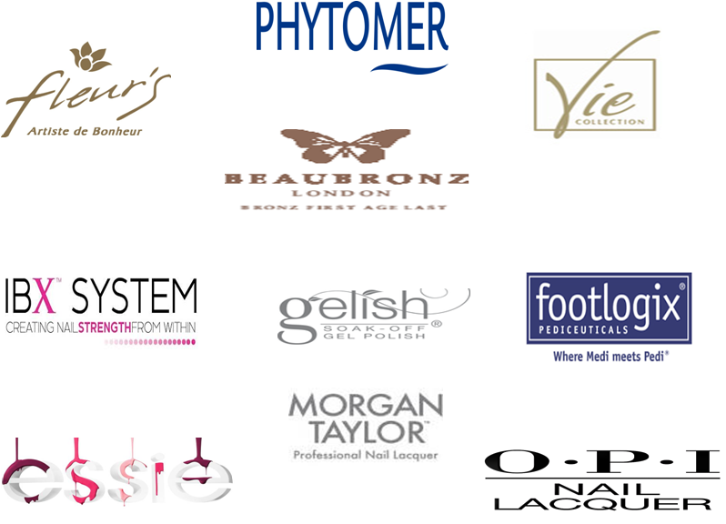

Our aim is to provide a thorough and professional service, carrying out treatments with a Holistic approach together with aftercare advice.

You will enjoy being pampered by our Professional Friendly Therapists and GlamFairies.

Contents

Page:

The Remedie Rooms’ Signature Treatments
These unique treatments created by Mariama in collaboration with a Marine Laboratory
in Brittany, France provide long lasting results.

Vie Collection Cosmeceutical Ultra-Concentrated Acid Peel Facial Treatment
Cutting-edge treatments & products entirely orientated towards anti-ageing with
premium results!
(Vie Collection - An exclusive brand by The House of Phytomer France)

Phytomer Facial Treatments
The highly sensorial and relaxing context of PHYTOMER treatments increases the scientifically-proven skincare benefits. Unprecedented French Marine cosmetic!

Body Wrap Treatments
Skin Cleansing Body Treatments

BeauBronz Natural Tanning Body Treatments

Massage Treatments

Sports and Deep Tissue Massage Treatments by Elvis Achu

Phytomer Sea Holistic Radiance Body & Face Treatment

Warm & Hot Wax Hair Removal for Men and Women

Eye Treatments:
Hands & Feet Remedial Treatments:

Hands & Feet Beauty Treatments

Client’s important information

THE REMEDIE ROOMS’ SIGNATURE TREATMENTS

Our luxurious treatments are especially designed to leave you detoxified, refreshed,
energised and to relieved aches & pains.

Ultrasonic Deep Facial treatment – 1h00:  This non-invasive treatment will stimulate skin elasticity, reduce open pores, boost collagen, reduce deep wrinkles, provide a lift effect and leave your skin hydrated, moisturised and youthful with long lasting results.  (We recommend this treatment once a month for optimum results over the winter and every 6/8 weeks during the warmer months) | £60.00
Remedie Mud Detox Pedicure -1h15:  A luxurious feet treatment with the added benefit of a self-heating detoxifying seaweed mask wrap. (We recommend this treatment once a month for optimum results.) | £41.00
Remedie Perfect Manicure – 1h15:  A luxurious hand treatment with the added benefit of an exfoliation and moisturising mask wrap. Optimum treatment and results for tired, dry and damaged hands and nails.  (We recommend this treatment once a month for optimum results – Ideal for those who lift weights in the gym.) | £30.00

VIE COLLECTION – THE COSMECEUTICAL EXPERT.
“A WORLD OF LUXURY AND PERFORMANCE”

Vie Collection is an “Avant-Garde” Dermo-Cosmetic Brand, inspired by aesthetic medicine.
Vie collection develops original youth solutions and unprecedented beauty treatment procedures.

Vie Collection’s products stand out with high-tech formulas and advanced ingredients which deliver to the skin maximum youth effectiveness.

Vie Collection star ingredients and major scientific discoveries are patented and integrated in products that are increasingly innovative and effective.

“UNMATCHED STANDARDS OF PRECISION & EFFECTIVENESS IN A PRESTIGE RANGE FOR ALL WHO DEMAND EXCELLENCE”

ULTRA-CONCENTRATED ACID PEEL FACIAL TREATMENT

Course of 3 treatments which includes your
“Accelerated Recovery Treatment daily Cream”.
(Over 3 to 4 weeks)
£195.00

First Treatment: 01:00 / Follow-up Treatments: 00:45

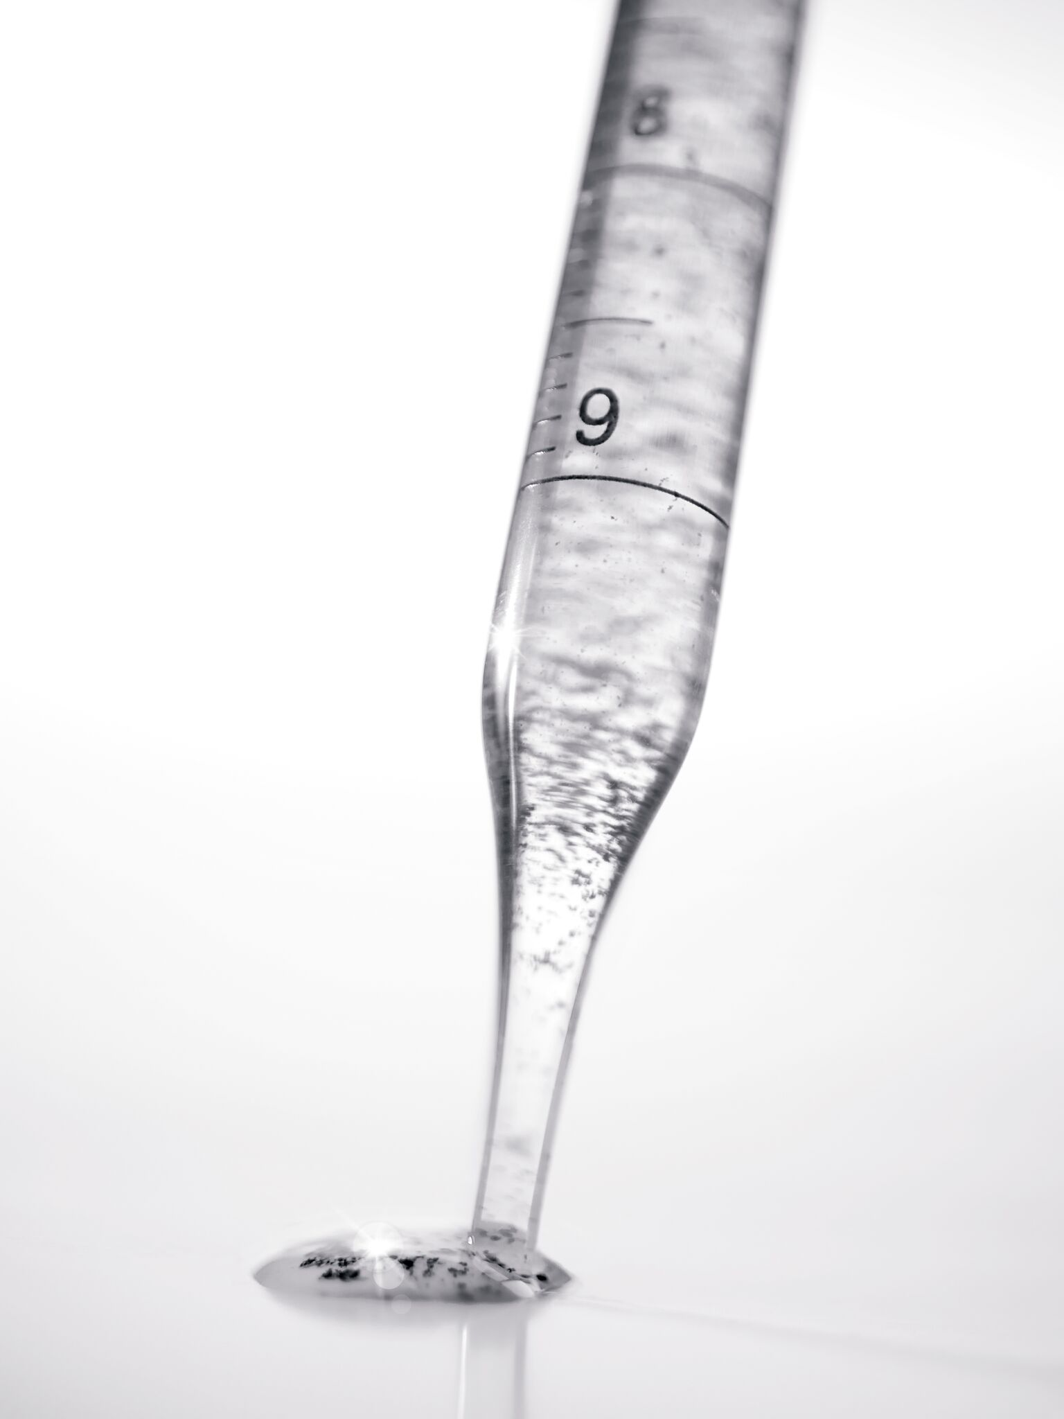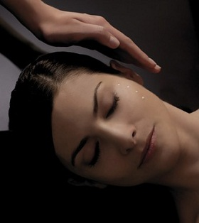

Medically inspired exfoliation to renew the skin.
While ensuring optimal tolerance, it provides complete skin resurfacing to correct skin imperfections and signs of ageing.

The objective: Perfect skin and “instant rejuvenation”.
From the 1st treatment the complexion is more radiant, dark spots fade and wrinkles diminish.

We recommend a single treatment from time-to-time after summer holidays or
to prepare for a special occasion.
1 treatment: £75.00
(Does not include your “Accelerated Recovery Treatment Cream” which can be purchased separately).

(Fleur’s by the House of Phytomer)

PHYTOMER FACIAL TREATMENTS
“THE WORLD LEADER IN MARINE COSMETIC”

Our unique facial treatments for Men & Women begin with a relaxing back massage targeting reflex zones with the unique application of Detoxifying Self-Heating mud to the spinal column.

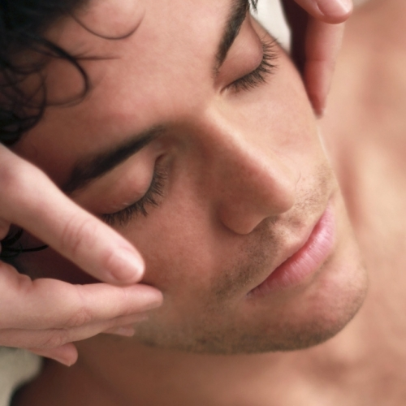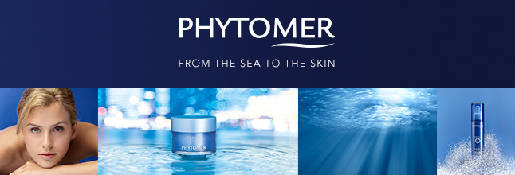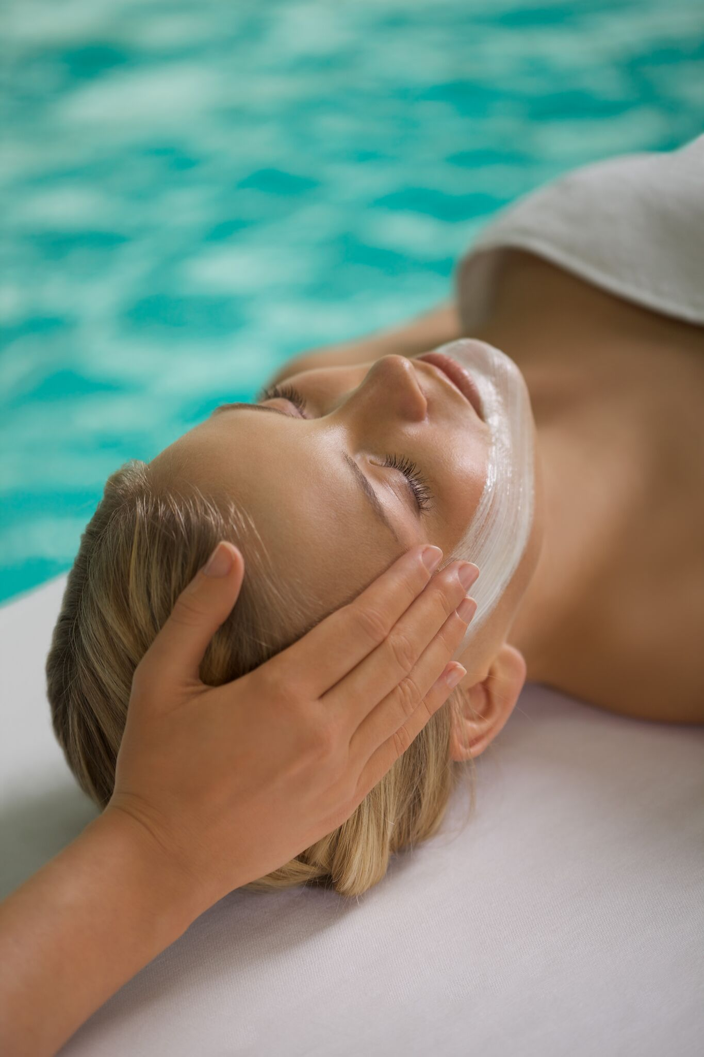

Beauty From our Planet Life Source: The Sea………High performance Products you can trust…

 |  | Course of 5
Phytomer Pionnere Youth Revealing Facial - 1h15:  Wrinkles correction Firming treatment: 3 key steps in a very high-performance treatment to resurface the skin, fill wrinkles and restructure the face. After 1 treatment, wrinkles are visibly reduced and the skin is firmer. At the high-end of scientific expertise and excellence this Youth Revealing treatment offers unique results paired with a precious moment of total well-being. | £68.00 | £270.00
Phytomer Citylife Anti-pollution Skin Freshness Facial - 1h15:  Brightening, oxygenating & detoxifying treatment: This Pollution shield beauty treatment is a real breath of oxygen and brings all the benefits of a seaside stroll into a treatment room. Provide two deep-cleansing masks. Shine and blemishes are reduced. Luminosity is restored to the complexion and the skin is cleansed and purified. | £68.00 | £270.00
Phytomer Hydra-Blue Plumping Moisturising Facial - 1h00:  Treat dehydration, dryness, gives radiance, moisture and nourishment: This treatment perfectly balances effective moisturising and intense relaxation. It combines signature products with ultra-sensory textures and a very relaxing facial massage to moisturise and comfort the skin, which instantly reveals its natural freshness. | £68.00 | £270.00
Phytomer Comforting Soothing Facial - 1h00:  Calms, soothes, reduces redness and irritation: A halo of softness for skin that is sensitive or subject to redness. This cocoon treatment softens the skin and improves its defence for a soothed and ideally hydrated epidermis, producing a radiant complexion. | £68.00 | £270.00
Phytomer Prescription Facial – 00h55:  Choose from any of the above facial treatments.  (Please note that this treatment does not include a back massage & the application of self-heated mud). | £62.00
Phytomer Marine Eye Life – 00h45:  Relaxing treatment designed to soothe, decongest and invigorate the eye area.  (This treatment will be charged £30.00 when combined with any of the above Facial Treatments). | £40.00
BODY WRAP TREATMENTS

MÉLODIE OCÉAN  MICRONISED MARINE ALGUE DETOX BODY WRAP - 1h00: | £57.00
Step into a cocoon of well-being and experience a world of marine
Beauty which will soothe away tensions & restore your energy balance.
Immerse your body in the richness of marine algae & let it infuse its wealth of minerals, vitamins & micro-nutrients to your skin for intensive re-mineralisation & detoxification. It combines a full body exfoliation and a warm body wrap.
This treatment activates circulation, relieves aches & pain and provides deep relaxation

(£40 only prior to a course of Sudatonic Body Treatments – details above)

INTENSIVE MOISTURISING BODY WRAP - 00:45 |  | £55.00
A treatment to re-hydrate dull, dry and tired skin. It combines a full body exfoliation, a warm body wrap & the application of an intense moisturiser.
It will leave your skin well moisturised, soft and rejuvenated.

SKIN CLEANSING BODY TREATMENTS

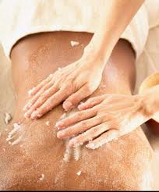

Ocean Glow Body Polish – 00h45:  A full body exfoliation treatment, which includes the application of an intense moisturiser. Ideal as a stand-alone treatment or prior to any course of treatment. Recommended prior to any course of treatments for maximum results. |  | £48.00
Ocean Oxygen Back Facial - 00h30:  Ideal for dull, sluggish and congested skins of all ages. Includes a back exfoliation and the application of self-heated mud to open blocked pores and totally decongest the area. |  | £48.00
Ocean Glow Back Polish - 00h30:  A back exfoliation treatment which includes a relaxing massage.  It will leave your skin silky-smooth. |  | £46.00

BEAUBRONZ NATURAL TANNING BODY TREATMENTS

A luxurious, odourless and paraben free tanning treatment containing organic and natural ingredients.
“This tan will leave you with a natural sun kissed look!”

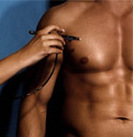
Ocean Glow Body and Face Spray Tan – 00h60:  A top-to-toe exfoliation treatment (Body and Face) followed by a full body spray tan, by Beaubronz.  (Ideal treatment to professionally prepare your skin for a long lasting perfect natural tan.) |  | £60.00
Beaubronz Full Body Spray Tan – 00h30:  Luxurious, paraben free tanning treatment. |  | £30.00

Beaubronz is the official spraytan for
“Dancing On Ice”, “Miss GB Contest” & Peter André: “Bad Boyfriend Club”.

THERAPEUTIC MASSAGES

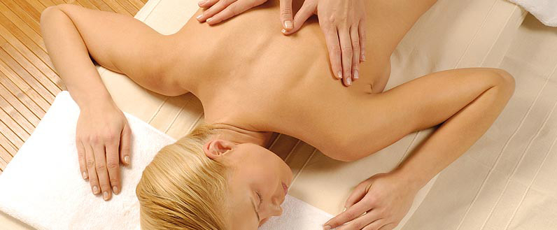

A selection of treatments to relax, reduce tension, relieve the negative effect
of everyday stress and to leave you with a feeling of well-being.

Aroma Therapy Full Body Massage – 01h00:  We use pure essential oils of the finest quality. They will nourish and stimulate the skin, enhance the immune system & delight the senses. |  | £62.00
Therapeutic Swedish Massage:  A stimulating and invigorating treatment. A must for hard worked bodies to relieve muscle fatigue.  Half-body – 00h30:  Full-body – 01h00: | £39.00  £55.00 | Course of 6  £185.00  £200.00
Hot Candle Massage for Back – 00h30:  A new concept in massage designed to provide the ultimate ambiance by providing a subtle form of lighting whilst at the same time delivering a sensuous aroma of pure essential oils & a unique massage medium. | £44.00
Invigorating Scalp Massage – 00h20:  Using acupressure techniques this treatment will increase blood and oxygen supply to the scalp whilst reducing stress and mental fatigue. | £27.00
Mother-to-be-Body Massage – 00h45:  A stimulating and invigorating treatment for hands, feet and legs with the use of our Soothing Leg Gel. | £46.00
Foot Massage – 00h20: | £11.00

SPORTS AND DEEP TISSUE MASSAGE TREATMENTS
PROVIDED BY ELVIS ACHU.

Minor injuries caused by every day activities are the most common musculo-skeletal problems. However, these are often not adequately dealt with in spite of the fact that they may be exceedingly painful and seriously affect a person’s occupation, sport or quality of life.  If left untreated, minor injuries may develop into a chronic and more serious condition, having a knock-on effect on other muscles and eventually the joints.  Sports Massage is a deep tissue massage that is used therapeutically to break up scar tissue and lesions and to release tight aching muscles. It may be used for injury prevention, not just in a sports context but also in terms of posture and other forms of stress such as repetitive strain.  00h30:  01h00:  01h30: | £40.00  £60.00  £80.00 | Course of 6  £190.00  £295.00 | Course of 12  £380.00  £590.00
Deep Tissue Massage is used to treat chronic muscle tension through slow strokes and direct deep pressure or friction applied across the grain of the muscles not with the grain.  This massage may help to break-up and eliminate scare tissue.  It is an excellent massage to help to get rid of deep rooted knots especially in the neck, shoulders and legs. It may cause some soreness during or right after the treatment, but you will, however, feel better than ever within a day or two.  00h30:  01h00:  01h30: | £40.00  £60.00  £80.00 | £190.00  £295.00 | £380.00  £590.00

SEA HOLISTIC RADIANCE BODY & FACE TREATMENT

Inspired from the beneficial properties of the marine world together with Holistic Thai massage techniques and Phytomer’s unique Sea Salt and lavender bolus.  This treatment is designed for the Face & Body and brings about a unique moment of relaxation and tranquillity, whilst leaving the skin exquisitely silky and smooth.  It combines a full body exfoliation, a prestige facial and the application of hot bolus followed by a pressure point massage.  (We recommend this treatment once a month for optimum results.) | 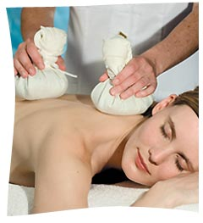  01h30  £100.00 per full body treatment  (IDEAL AS A GIFT)

HAIR REMOVAL FOR MEN AND WOMEN
 | WARM WAX | HOT WAX
Eye Brow: | £10.00 | £12.00
Lip or Chin:  Lip & Chin: | £9.50  £13.50 | £10.50  £14.50
Eye Brow, Lip & Chin: | £22.00 | £24.00
Bikini:  G- String (High Bikini):  Brazilian (Strip Shape):  Hollywood (Everything off): |  | £18.00  £24.00  £34.50  £40.50
Underarms: |  | £14.50
Bikini & Underarms: |  | £24.00
Half Leg (add £4.00 for Men): | £24.00
Three Quarter Leg (add £4.00 for Men): | £28.50
Full Leg (add £4.00 for Men): | £34.00
Half Leg & Bikini | £28.50
Three Quarter Leg & Bikini: | £32.00
Full leg & Bikini: | £38.50
Forearm: | £20.00
Full arm: | £23.00
Sides & Neck: | £14.50 | £16.50
Stomach: | £18.00
Buttocks: |  | £37.00
Full Men Chest or Full Men back (add £3.00 for extra-hairy): | £27.00
Full Men Chest & Back: | £47.00

EYE TREATMENTS

Phytomer Marine Eye Life – 00h45: £40.00
Relaxing treatment designed to soothe, decongest and invigorate the eye area.
(This treatment will be charged £30.00 when combined with a Facial Treatments).
Eye lash & brow tint: | £25.00
Eye lash tint: | £15.00
Eye brow tint:  Please note that tinting treatments require a test patch at least 48/24 hours prior to first application. | £14.00

HANDS AND FEET REMEDIAL TREATMENTS

Hands and feet treatments for mild to severe nails and skin conditions.

IBX SYSTEM TREATMENT  Creating Nail Strength From Within For Longer, Stronger & More Beautiful Nails!  IBX System is a revolutionary protective treatment system for use under all natural or gel polishes.  It is the key to protection from soak-off damage and the solution to weak, damaged, peeling nails in only a few applications.  IBX System repairs penetrate into the nail plate and works to toughen from the inside out.  It is the first treatment of its kind as it is applied like a polish, cured with LED or UV light, works inside the nail as opposed to sitting on top and requires no removal.  IBX System can also be worn as clear polish. | 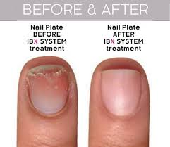  00h20  £18.00 per treatment  01h15  £37.00 per treatment with Gelish application
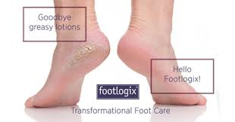  00h45  £36.00 per treatment  00h60  £44.00 per treatment with full colour pedicure | FOOTLOGIX PEDICEUTICAL TREATMENT  Footlogix® is the world’s first and only PEDICEUTICAL® Foot Care line scientifically formulated which is made with pharmaceutical grade ingredients.  Footlogix’s unique ground-breaking Dermal Infusion Technology® enables active ingredients to penetrate faster and deeper into troubled skin of the feet.  With results seen in a mere few days, from curing simple dryness to addressing more severe conditions such as Diabetes.  Footlogix® Pedi-CARE has been clinically proven to help in association with our recommended daily homecare.

HANDS AND FEET BEAUTY TREATMENTS

Luxurious hand and feet treatments for all to enjoy. Includes cuticle soak & tidy and
A massage before the nails are shaped and finished with nail polish.

Remedie Paraffin Wax Pedicure: | £46.00
Remedie Mud Detox Pedicure or Remedie Perfect Manicure:  See The Remedie Rooms’ Signature Treatments for further details | £41.00 | £30.00
Manicure / With French polish: | £25.00 | £26.50
Pedicure / With French polish: | £28.00 | £30.00
File & re-varnish Hand / With French Polish: | £15.50 | £17.50
File & re-varnish Feet / With French Polish: | £16.50 | £18.50
Foot Massage: | £11.00
Foot Massage with pedicure: | £35.00
Hand Massage with Manicure: | £31.00

GELISH: THE WORLD FIRST GEL POLISH SYSTEM
Luxurious gel polish in an array of colours offering no chipping, smudging or
shrinkage and quick drying time.

Gelish Hand Application - Colour:  Gelish Gel Hand Application – French Manicure: | £25.00  £27.00
Gelish Gel Feet Application - Colour:  Gelish Gel Feet Application – French Manicure: | £27.00  £29.00
Gel Soak-off:  Other brands of gel which we did not apply  Free when re-applying Gelish Polish which we did for you previously  (Please note a Gelish application includes: filling, push-off the cuticles & painting) | £7.50  £10.00

MANICURE OR PEDICURE WITH GELISH APPLICATION: £30.50/£33.50
(Please note for your wellbeing cuticles will not be cut but pushed-back for this treatment)
Hygiene and safety protocols are paramount to our work!
Thus, we provide natural nail care only and will not perform or remove any acrylic enhancements or powders which means you will not be subjected to horrid fumes or smells during your visit to The Rooms. We do not use drills or e-files. We only treat your nails with pure natural love!

CLIENT’S IMPORTANT INFORMATION

General:
- For you comfort, we suggest you arrive at least 10 minutes before your scheduled start of treatment.
- Do not have any heat treatments before or after waxing. This includes sunbeds, sauna, steams, swimming & sunbathing.
- Do wear dark loose clothing before & after tanning treatment and no jeans.
- Do wear underwear when having a body or massage treatment.
- A test to safeguard against allergic reactions is required 48 to 24 hours prior to any first Tint Treatment with us. Our health and skin changes from time to time and we will repeat this test once a year for all Clients whom stop tint treatment for more than a year.
- Please do have a quick shower especially after exercising before a body or massage treatments.
- Alcohol should not be consumed prior to treatment and should be avoided after certain treatments or consumed in moderation. Your GlamFairies will inform you when it is the case.
- Every effort will be made to provide you with your preferred Therapist but cannot be guaranteed at all times.
- Do tell us immediately if your treatment did not reach your expectations.
- Certain treatments are not suitable for expecting Mothers but we will offer an alternative treatment.
- Do let us know or update us as necessary if you have any medical conditions and/or allergies or change your contact details.
- Our experienced Therapists will perform a full facial and/or body consultation prior to any facial or targeting body treatment in order to determine which treatment will be suitable for your skin or body type.
- Your GlamFairies are Child Friendly just let us know when booking that you are coming with the little Joy(s).
- We do offer monthly Special Promotions which you can find on our social media. You will also receive our monthly e-mail update.

Booking, Cancellation & Pricing:
- You can book your treatment directly on-line via our website: www.theremedierooms.com or Facebook.
- All prices are subject to change without prior notice.
- Please arrive at least 10 minute before your appointment.
- Do offer to pay for your manicure before the treatment & take car keys or bus/train pass out of your handbag ready for when you leave.
- A gratuity payment can be made directly to your Therapist or at the Reception Desk. It is kindly appreciated.
- Please note that we require 24 hours notice to cancel or re-schedule appointments otherwise a 50% charge will be made. Failure to arrive to an appointment will incur the full charge.
- Credit/Debit Cards payments over £10 only will be accepted – Cheques are not accepted.
- Courses of treatments are available for a maximum period of 12 month. Please enquire when making your booking.
- Corporate rate discounts available for Company registered with us, please ask for further details.
- Local Gym & Studio Members receive a 15% discount on treatments (not retail) Information on participating Clubs can be found on our website. If you would like your Gym or Studio to join our scheme, please do get in touch.

Mobile phones, Data security & Valuables:
- We respectfully request that all mobile phones be switched off during your visit in The Rooms.
- Personal details taken from Clients during consultation procedures will be kept secure and in the strictest confidence at all times.
- Some of our treatments require the removal of jewellery, which will be stored safely in your treatment room. Please ensure that you retrieve all your valuables before leaving the premises, as we cannot be held responsible for lost items.

“Gift Certificate” and “Loyalty Cards”:
  - You can purchase Gift Certificates for treatments or money value by visiting us, over the telephone or via e-mail.
  - We will provide you with our Loyalty Card on your first visit to The Remedie Rooms.

Your Favourite GlamFairies wish to thank you for your loyal custom for the last 14 years.
Opening Hours:

Monday/Tuesday: Closed
Wednesday to Friday: 10:00 – 20:30
Saturday: 10:30 – 18:30
Sunday: 12:00 – 16:00 (2 Sundays per month)

(Please note that our opening hours may vary from time to time. Check our website for more information)

www.theremedierooms.com
enquiries@theremedierooms.co.uk
enquiries@theremedierooms.com

Follow us on:  Facebook: https://www.facebook.com/TheRemedieRooms/  Twitter: https://twitter.com/RemedieRooms16  Instagram: theremedierooms  Don’t forget to download our mobile app for easy of booking:   | 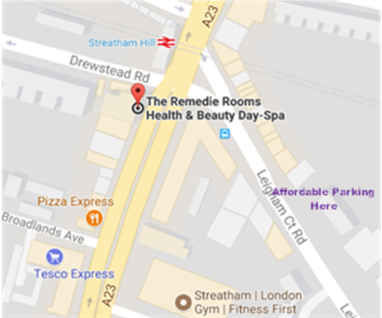  For convenience:  Don’t forget to park in the Lambeth Affordable parking as shown above which is only a minute walk away from The Rooms.

